**Commodore VIC-20 A/V-Adapter Rev. 0**

**Module Description**

# Introduction

The VIC-20 A/V-Adapter serves as a breakout module for the 5-pin A/V jack, which allows using off the shelve cables of desired length and quality for connecting the VIC-20 to video/audio equipment.

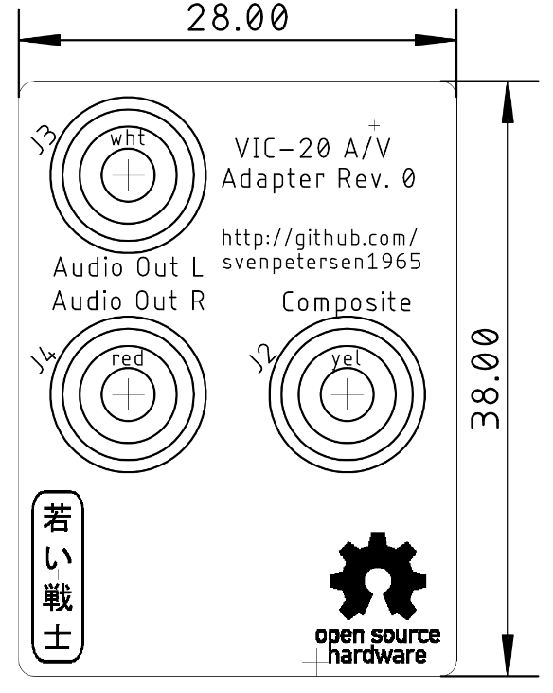

Figure 1: Dimensions of the PCB

The two audio jacks (Audio L and Audio R) are connected to the same signal, the (mono) Audio Out of the VIC-20.

A 3D printable case can be found in the project folder as well as a label for this case.

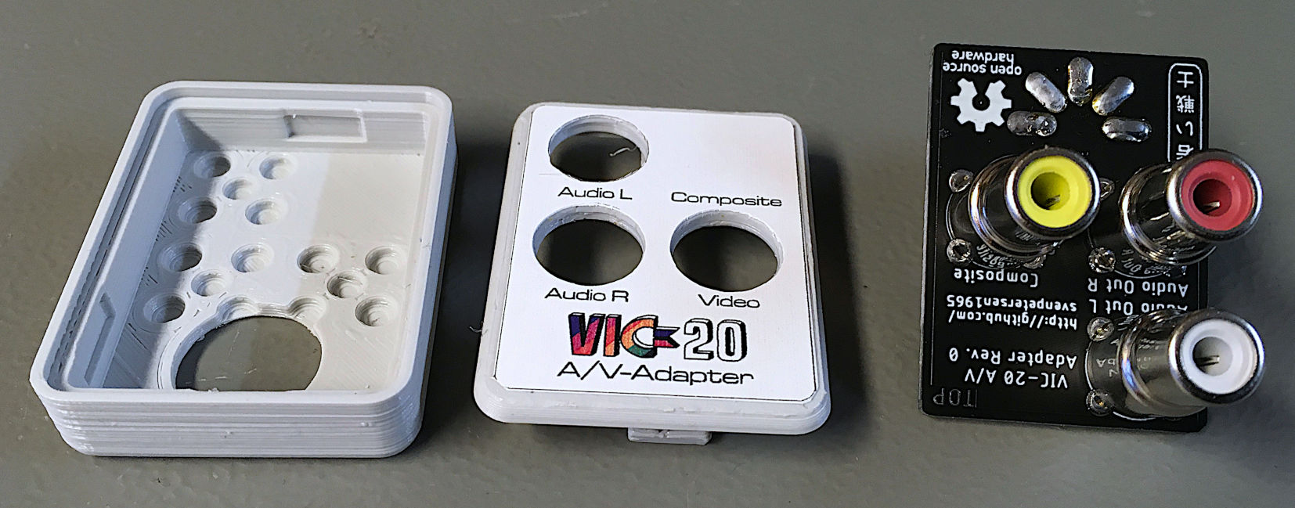

Figure 2: 3D printed case and assembled PCB

# Connectors

## A/V-Plug – J1

The A/V-Plug for the VIC-20 is the inner part of a Lumberg SV 50 DIN-Plug (180°).

|  |  |
| --- | --- |
| Pin | Signal |
| 1 | n.c. |
| 2 | GND |
| 3 | Audio Out (mono) |
| 4 | Composite Video |
| 5 | n.c. |

## RCA-Jacks – J2, J3, J4

|  |  |
| --- | --- |
| Connector | Signal |
| J2 | Composite Video |
| J3 | Audio Out L (mono!) |
| J4 | Audio Out R (mono!) |

# The DIN-Plug

The DIN-Plug is an **essential part** of this development. It is the inner part of a Lumberg SV 50 connector, which is not cheap, but it is definitely worth the money, since the flange is taking the forces introduced by the weight of the adapter and the cables. This way, the set-up is not hanging from the contacts, which might even damage those. Do not use a cheap connector without a flange, here.

# Assembly

First, the DIN connector has to be soldered. The pins should be aligned flush to the top side of the PCB. This can be accomplished by putting the PCB top down on a heat resistant, flat surface. Then solder one pin from the top (the solder pads are shaped in a way, that allows doing so), check, if it is really flush and the connector is perpendicular to the board, then solder the remaining pins.

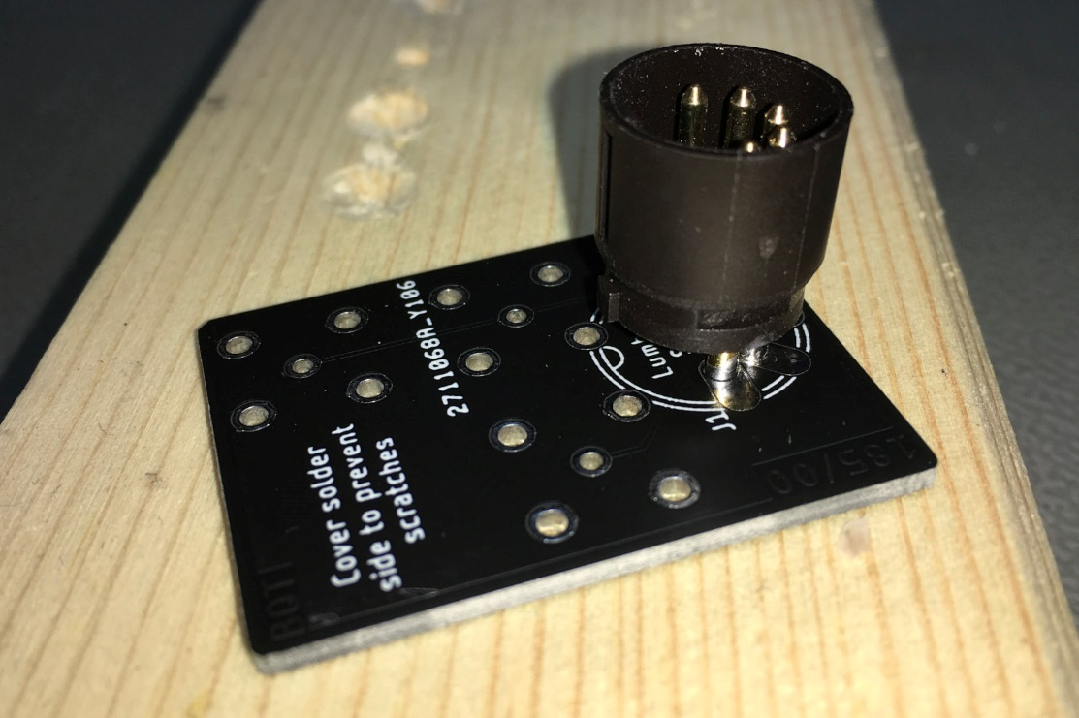

Figure 3: Aligning the DIN-Connector

Now, place and solder the RCA jacks. They should be well aligned, too. The ground pins might require more energy to be soldered, so the use of a thick solder tip is recommended and may be even a higher temperature (450°C). After soldering, the pins should be trimmed (shorter than 1.5mm), so they fit into the 3D-Printed case. If you do not use a case, cover the pins with something like duct tape or small drops of hot glue to prevent scratching the case of your VIC-20.

# Compatibility

The adapter also fits the C64 (in case S-Video is not required), especially the first C64 model with the 5-pin A/V-jack (this does not have the S-Video outputs). The same is for the C16. The A/V-Adapter does not work for the C128, since it blocks the serial bus. The adapter was successfully tested with an Atari 800XL.